Single Row functions

1. To list all employees and their email, to generate email use 2 to 5 characters from ename

Concat it with 2 to 4 characters in job and then concat it with ‘@mycompany.com’

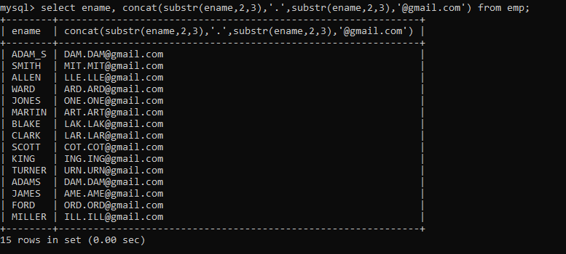

2. List all employees who joined in September.

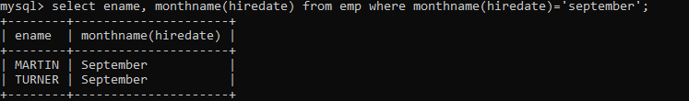

3. List the empno, name, and department number of the emp who have experience of 18 or

more years and sort them based on their experience.

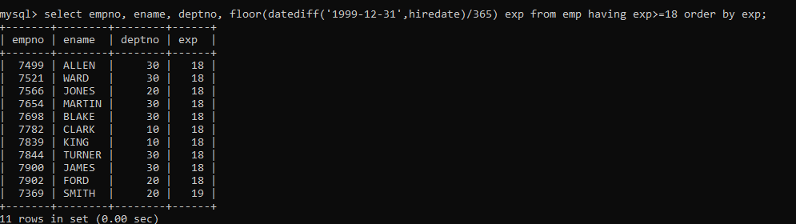

4. Display the employee details who joined on 3rd of any month or any year

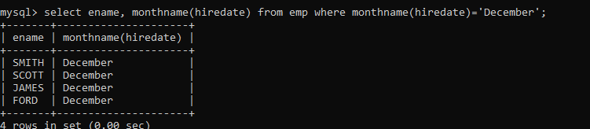

5. display all employees who joined between years 1981 to 1983.

